
Job Description and Person Specification

Post and Specialty | Consultant in Community Paediatrics  https://www.leicspart.nhs.uk/service/community-paediatric-service/  This Replacement post arises due to internal organisational changes.
Royal College of Paediatrics approval details: | RCPaeds Ref No: 20251107SS34 – Approved    The Job Description was approved on 21/11/2025 by Dr Rajesh Sardana. The approval is valid for 12 months.
DBS Level | Enhanced DBS with Both Adults and Children’s Barred Lists
Base | Pen Lloyd Building, County Hall, Leicester Road, Glenfield, Leicestershire LE3 8RA
Contract | Permanent
No. of Programmed Activities | Total PAs:10 | DCC: 7.5 |  | SPA: 2.5
Accountable professionally to | Medical Director
Accountable operationally to | Clinical Director for the Families, Young People and Children’s Services
Key Working Relationships and lines of responsibility | Director |  | Tiffany Webster
Key Working Relationships and lines of responsibility | Associate Medical Director (FYPC LDA Service) |  | Dr Rohit Gumber
Key Working Relationships and lines of responsibility | Clinical Director |  | Dr Subramanian Ganesan
Key Working Relationships and lines of responsibility | Service Manager |  | Sarah Baines
Key Working Relationships and lines of responsibility | Head of Service |  | Victoria Evans
Key Working Relationships and lines of responsibility | Responsible Officer |  | Dr Bhanu Chadalavada
Key Working Relationships and lines of responsibility | Medical Director |  | Dr Bhanu Chadalavada
Key Working Relationships and lines of responsibility | Chief Executive |  | Angela Hilery
Key Working Relationships and lines of responsibility | Deputy Chief Executive |  | Jean Knight
1. Introduction

Leicester, Leicestershire and Rutland (LLR) is rich in culture, heritage and leisure activities, from a vibrant multi -cultural city, to the market towns and rural settings and has a population of over 1 million.

Leicester is home to the state of the art Curve Theatre, as well as large and multi-cultural festivals. The city hosts an annual Pride Parade (Leicester Pride), a Caribbean Carnival, the largest Diwali celebrations outside of India and the largest comedy festival in the UK. The area features award-winning family attractions on your doorstep including Twycross Zoo, the National Space Centre, and Twin Lakes Park. Discover Roman ruins, majestic castles and historic events, including the Battle of Bosworth re-enactment at Bosworth Battlefield; or visit the King Richard III visitor centre. Experience top high-street and designer shopping in Leicester or browse the markets in our market towns.

Our central location in the heart of the Midlands makes Leicester, Leicestershire and Rutland accessible from all directions. It takes just 60 minutes to come to Leicester on a fast, direct train from London
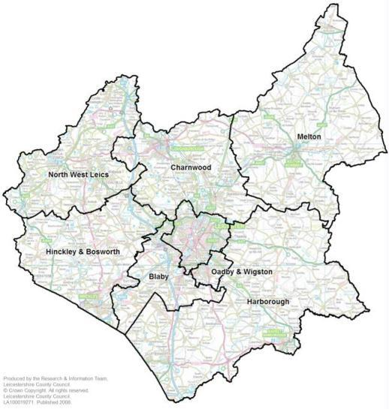
Leicester

2. Who we are

We (Leicestershire Partnership NHS Trust) are an integrated mental health, community health and learning disability services provider for all ages. Our 6,500 staff and volunteers provide services through over 100 in-patient and community settings, as well as in people’s homes, across Leicester, Leicestershire and Rutland.

Our collective vision is to create high quality, compassionate care and wellbeing for all –
with quality and safety as our number one priority.

Our strategy: Together we THRIVE

We are proud of our mission, vision and strategy, which will help guide our work and priorities for the next five years, aligned to the NHS Ten Year Plan. We’ve developed these jointly, as Leicestershire Partnership and Northamptonshire Healthcare Associate University Group, to set out how our independent organisations will work together to improve health outcomes for our local communities and help the people we support to thrive.
Our vision is aspirational; it is where we want to be in 2030. It is what will inform our planning and help us to make decisions. Our new vision is: Together we THRIVE; building compassionate care and wellbeing for all.
Our mission is our daily driver; it’s why we turn up to work every day to do what we do. Our new mission is: Making a difference, together.
Our strategy is our enabler; the vehicle that will help us to take our day-to-day mission and build upon this to reach our vision. We call it THRIVE, and it stands for six strategic priorities:
- T – Technology
- H – Healthy communities
- R – Responsive
- I – Including everyone
- V – Valuing our people
- E – Efficient and effective​
Underpinning all of this is our values and leadership behaviours for all. Our values of compassion, respect, integrity and trust guide us in everything we do. At LPT everybody is a leader and our Leadership Behaviours for All emphasise the culture we are committed to nurturing, where everybody is making a difference together to thrive.
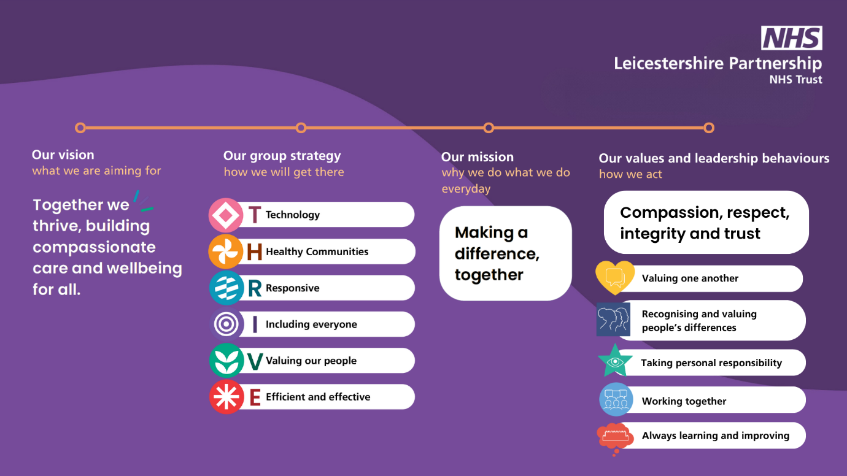
We are committed to providing high quality services with a focus on continuous improvement. We want to help build thriving, healthy communities, and co-produce care delivery pathways that provide the types of care our service users need, making the most of resources at our disposal. We will continue to be responsive, innovative, and inclusive. We want the thousands of people who work for our Trusts or in our partnerships to know they are valued. Our Group strategy helps us to maintain a strong and clear record for working proactively to improve, learn and share together with a focus on delivering compassionate care and wellbeing for all.
We hold Associate University Group status, which underlines our commitment to working closely with our universities. LPT is a teaching trust, conducting research and providing training and education for medical, psychology, nursing and therapy students. We work in partnership with a range of educational establishments such as University of Leicester, De Montfort University and Loughborough University to deliver effective pre and post-registration education and learning opportunities.

Our Chief Executive, Angela Hillery, has worked within the NHS for over 30 years and has held a variety of leadership positions during this time. She has worked in the NHS for over 30 years, taking up the leadership of Northamptonshire Healthcare Foundation Trust (NHFT) since 2013 and becoming chief executive of LPT since 2019 as a combined role. NHFT and LPT entered into a Group arrangement in April 2021 following a successful buddy relationship.
In March 2023, Angela was named the top NHS CEO in the country by the Health Service Journal (HSJ), having been listed in the HSJ Top 50 for three years prior to this. In June 2023, Angela was awarded a CBE (Commander of the Order of the British Empire) in the first King’s birthday honours list – the highest-ranking Order of the British Empire award, other than a knighthood or damehood.
In 2018 and 2019 under Angela’s leadership, NHFT achieved an overall rating of ‘Outstanding’ from the CQC and also won the 2018 HSJ ‘Trust of the Year’ Award. LPT is committed to continuous improvement, sharing learning and adopting best practice.

As an employee of Leicestershire Partnership NHS Trust you can expect to receive an excellent benefits package, giving you access to a range of wellbeing opportunities and discounts on products and services. We have an occupational health service to support your health and wellbeing, staff physiotherapy service, confidential counselling service, mentoring for new Consultants, recognition awards for exceptional commitment and long service, corporate discounts for gym membership, health spa and much more.

Our Leadership Behaviours: It starts with me
Our leadership behaviours framework set the standards of expectation we aspire to in our daily work. Meeting these standards and developing the capability to exceed them, will not only ensure that we continue to improve and respond flexibly to changing needs as an organisation, but will also help our staff to fulfil their potential, both in terms of personal achievement and career advancement. Our leadership behaviours also promote compassionate conversations, respect and positive working relationships to enable us to support the wellbeing of our workforce, particularly following serious incidents.

The behaviours we expect to see at LPT are:

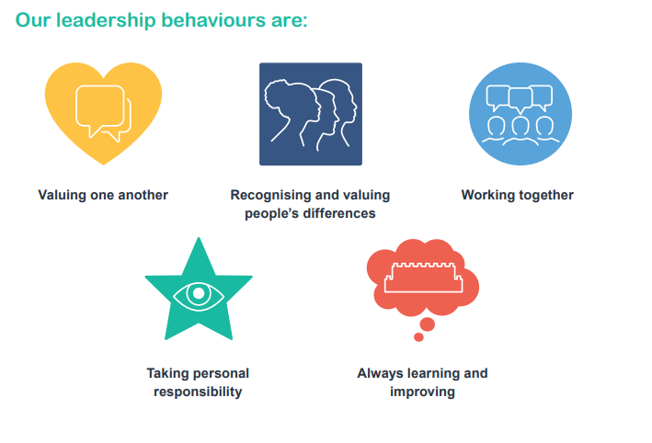
See Appendix 1 for further information.

3. Details of the service and team

The post holder will be based at County Hall (office base).

The post is for a Consultant Community Paediatrician (10 PA) working for the Division of Families, Young People and Children’s services.

We would welcome Consultant Paediatricians with experience in general and developmental paediatrics, assessment and management of neurodevelopmental disorders like ASD and ADHD, paediatric neurodisability and safeguarding. Experience in doing Initial Health assessments for LAC (looked for children) is expected as it would be an essential part of the job plan. Experience in adoption and fostering is welcome. Opportunities to develop specific management roles will be accommodated based on the clinical experience of the candidate.

The post holder will join other Consultants, Associate specialist grade and specialty doctors in the expanding work of locality-based Paediatrician-led community paediatric teams. The duties will require clinical leadership for aspects of child-care in a range of venues.

The Community paediatricians operate a daytime rota for safeguarding (physical and neglect). This is applicable Mon- Fri each week, excluding bank holidays.

The post will support the community based paediatric services in Leicester, Leicestershire and Rutland. The administrative base for this post is at County Hall, with clinical activity being carried out at various localities in Leicestershire. Office accommodation and secretarial support will be provided for the post holder.

Requests may be considered from applicants wishing to work alternative or fewer hours.

 | LEAD RESPONSIBILITY | SPECIAL INTEREST
Dr Subramanian Ganesan  (Consultant) | Clinical Director  RCPCH Tutor | Epilepsy/Neurology  Neurodisability
Dr Peter Felix  (Consultant) | Job planning | Education for UG
Dr Annette Shawcross  (Consultant) | End of life care | Neurodisability
Dr Shila Mistry  (Consultant) |  | Neurodisability  System one Digital transformation
Dr Alun Elias-Jones  (Consultant) | LLR Designated Doctor for safeguarding children
Dr Devanitha Sekaran  (Consultant) | Tone management | Neurodisability
Dr Neeta Kulkarni  (Consultant) | Research  ADHD | Respiratory- PCD clinics  Qb testing and training
Dr Mhorag Duff  (Consultant & Honorary Senior Lecturer) | Undergraduate training | Sleep Medicine
Dr Christo Benite  (Consultant) | Down’s Pathway | Neurodisability
Dr Sandip Ghosh  (Consultant & Honorary Lecturer) | Undergraduate training lead
Dr Guru Setty  (Consultant) | Autism pathway | Neuromuscular
Dr Priyha Santhanam  (Consultant) |  | Obesity
Dr Vaishali Pukale  (Consultant) | Named Doctor for Safeguarding children
Dr Witold Cieslak  (Consultant) | Named Doctor for Safeguarding children
Dr Suzanne Armitage  (Consultant) | LLR Designated Doctor for Child Death
Dr Durgesh Yewatkar  (Consultant) | Associate Clinical Director | Single point of access
Dr Vesna Augustic  (Consultant) | Named Doctor for LAC
Dr Nehal Thanawala  (Consultant) | Named Doctor for SEND
Dr Mahdieh Malekpour  (Consultant) |  | Looked after Children  Sleep Medicine
Dr Sarah Hughes  (Specialist grade doctor) | Adoption medical Advisor
Dr Rehana Parveen  (Specialist doctor) |  | Looked after Children
Dr Lynn Snow  (Specialist Doctor) | LLR Designated Doctor for Looked after Children
Dr Sweta Sangita  (Specialist Doctor) |  | Single point of access
Dr Paramjit Goraya  (Associate Specialist) | Fostering medical Advisor
Dr Anne Simpson  (Associate Specialist) | Adoption medical Advisor
Dr Shuang Wang  (Consultant) | Adoption medical Advisor
Dr Helen Unitt  (General practitioner) |  | Looked after children  Fostering medical advisor

4. Clinical Duties

The post holder will need to ensure that people who use services, carers and advocates are treated with respect and dignity

Clinical Work

Clinics are held regularly in a variety of venues throughout the health district, within the inner city and in the rural community hospitals. Consultants will be working closely with staff from Children’s Therapy and Children’s Nursing Services, the CAMHS teams, the staff of Children & Young People’s Education Service(s). Investigative facilities exist locally and access to a full range of investigative facilities exists at the acute hospitals where admitting rights are available.

Clinical Management
The postholder will contribute to Community Paediatric clinic and LAC clinics (looked after children) for IHA (initial health assessment). Looked After Children’s clinics are run by a team of 8 paediatricians who are dedicated to Children in Care Initial Health assessments as part of a wider job plan alongside 3 part time Adoption Medical Advisors, a named doctor for LAC and close links with the Designated Doctor for LAC. We have good admin support of CiC work and a large specialist nursing team and Care Navigators who support the implementation of the Health Plan and Review Health assessments. There are close links with the Local Authorities through operational and strategic meetings. We constantly seek to improve the child’s journey through QI projects, close data scrutiny and partnership working across LLR.

Each Paediatrician has managerial responsibility with a lead in a specific area and liaises closely with the managers across the Division. Paediatricians also have areas of clinical specialist interest. Although it is expected that the successful candidate will contribute to the clinical and managerial resources, there is flexibility in the type of interest the successful applicant will bring to or develop within the post. Active participation in clinical research, audit and continuing professional development will be encouraged. The post holder will participate in training, teaching and supervision, as applicable. The post holder will participate in the Consultant Appraisal process and fulfil professional requirements for Continuous Professional Development (CPD).

Safeguarding Service

Paediatricians are part of daily on call Safeguarding Medical rota (9AM to 5PM). Within office hours, the post holder contributes to providing a service in the assessment of children with concerns about physical abuse and neglect. The exact nature of contribution will be determined by the clinical director and the post holder.

5. Job Plan and Timetable- Template

The precise configuration of activities and duties will need to be negotiated between the post holder and the Clinical Director.

Provisional assessment of Programmed Activities (PA’s) in Job Plan:

Direct Clinical Care: (7.5 PA)
Combination of LAC clinics, Paediatric Outpatient Clinic + Clinical admin Safeguarding on call and MDT time

Supporting Professional Activities (2.5PA’s)
CPD, administration, research and medical audit
Peer Support and Supervision
Undergraduate and Trainees teaching etc.,

Total 10 PA’s

The following specimen timetable illustrates as an example how the consultant timetable may be arranged within the current framework (subject to negotiation) for a week.

Day | Time | Location | Work | Category
Monday | AM | Venue TBC | Community pediatric clinic weekly | DCC
Monday | PM | Flexible | Clinic admin- dictation, MDT liaison, report checks | DCC
Tuesday | AM | Venue TBC | LAC clinic weekly | DCC
Tuesday | PM | Flexible | LAC clinic admin | DCC
Wednesday | AM | Venue TBC | LAC clinic weekly | DCC
Wednesday | PM | Flexible | LAC clinic admin | DCC
Thursday | AM | MDT/Flexible |  | DCC
Thursday | PM | Prince Philip house for | safeguarding on call/ Flexible | DCC
Friday | AM | County Hall | Safeguarding peer review meeting  Doctors professional meeting  Doctors business meeting | SPA
Friday | PM | County Hall | Departmental teaching  Audits, research, QIP | SPA

A formal job plan will be agreed between the appointee and the Clinical Director three months after the commencement date of the post holder. The job plan will then be reviewed annually, following the Appraisal meeting or more frequently when there are changes regarding the pre-agreed workload. The job plan will be a prospective agreement that sets out a consultant’s duties, responsibilities and objectives for the forthcoming year. The appointee to the post will be supported in arranging an appropriate and suitable mentor.

6. Management Duties
- There are no formal management or leadership responsibilities attached to this role but the Trust is keen that Paediatricians are supported to take on additional key roles and become involved within LPT, dependent on interests and skills.

- The post holder will be required to work with other Paediatric colleagues to arrange prospective cover during periods of planned absence, including reciprocal cover duties.

- The post holder is expected to be actively involved with clinical governance within the service and Trust.

- The post holder will participate in service evaluation and information gathering exercises designed to gain a better understanding of the functioning of the service in order to monitor performance and underpin future service development.

7. Secretarial support and office facilities
There will be dedicated secretarial/administrative support for the medical team (consultant and junior medical staff) supported by a team administrative structure.

The post holder will have access to designated private office space which will be equipped with appropriate information and communications technology to include access to Trust clinical systems. The post holder will be provided with a personal computer and/or laptop and mobile telephone.

Support will be provided for any mobile working as appropriate with technical support provided by the Leicestershire Health Informatics Service.

8. Education – Teaching and Training

Leicestershire Partnership NHS Trust is a teaching organisation. The Director of Medical Education is Dr Srinivas Suribhatla. The Trust has a dedicated Education Centre near to the Bradgate Mental Health Unit on the Glenfield Hospital site.

There are plenty of opportunities for candidates interested in undergraduate or postgraduate teaching. There are also opportunities for the successful candidate to contribute to the education of students in other professions. There is an active postgraduate training programme in place for trainees.

The 2013 GMC Good Medical Practice document (Domain 3 teaching, training, supporting and assessing 39-43) clearly states that all doctors should be willing to contribute to teaching, training, appraising and assessing doctors and students because these activities are fundamentally important to current and future patient care. LPT is a teaching Trust and Consultants will normally have undergraduate medical students placed with them during clinical duties and are expected to teach alongside clinical service work as part of their duties with time embedded in Direct Clinical Care (DCC) activities to undertake this role.

Medical students based at the University of Leicester follow a standard 5 year programme. Both ward and outpatient based clinical teaching, as well as tutorial and lecture style teaching is undertaken.

In addition some consultants will undertake additional undergraduate teaching duties which will be recognised as part of their SPA allowance (0.5 PA – 2 hpw) and recorded in their job plan. They will be recognised as Clinical Teachers where they meet the required criteria.

This teaching can occur in different settings. The clinical teacher will be expected to show evidence of satisfactory performance in this role at appraisal.

Principal Elements:
- To support and oversee the placement of students in the department and act as a clinical teacher
- To facilitate delivery of undergraduate teaching as directed by the departmental undergraduate education lead
- To volunteer and act as an examiner at formative and summative undergraduate professional examinations

Enhanced undergraduate duties will include acting as examiners in medical school assessments, providing occasional seminar and small group teaching, lecturing & other Phase 1 teaching within the medical curricula, in addition to individual supervision of clinical students attached to them.
Those who have an additional significant responsibility as a block or clinical education lead within their DCC time are also considered for the award of the title of honorary lecturer or honorary senior lecturer depending on their level of activity.
The exact duties to be undertaken will be determined by the Associate Medical Director for Medical Education in liaison with the Clinical Education/Block Leads, who are responsible to the Head of Leicester Medical School.

All members of medical staff are actively encouraged to take advantage of the Postgraduate Training programme. The Trust employs a Postgraduate Medical Education lead and three Consultants are designated as Core Educational Tutors.

There are libraries at each of the hospitals and teaching facilities and a Teaching and Staff Development Centre on the Glenfield Hospital site for multi-disciplinary use. There are journal clubs, regular audit meetings and an Open Programme as part of the Postgraduate teaching.

9. Continuous Professional Development (CPD)

Newly recruited Consultants will attend the mandatory Trust induction and be provided with a local induction within the Service. The Trust encourages new consultants to work with a mentor and will support consultants with this.

It is expected that the post holder will take part in appraisal and be in good standing for CPD with the Royal College of Paediatrics. The post holder will have access to study leave, and funding for appropriate courses, as agreed by the Trusts’ Study Leave Committee.

Each consultant will have access to funds within the medical educational and professional leave budget and there is an allowance of 30 days over a three year period to support CPD. The Trust study leave fund and policy is managed by the Medical CPD Committee to include Consultant reps from each service area.

10. Research and Development

LPT considers research to be core business for the organisation, and is committed to providing opportunities to both develop, host and collaborate in high quality research as a key driver in improving patient care and outcomes and to help us “Step Up To Great”. The Trust is a “Category A” partner organisation of the NIHR Clinical Research Network, and as such, is obligated to support NIHR Portfolio research where the capacity exists to do so. This often means working with national and international partners as Sponsors, with funding from both commercial and non-commercial agencies. The Trust is also actively participating in the NIHR East Midlands Applied Research Collaborative (ARC), and the NIHR Academic Health Sciences Network (AHSN) as well as local initiatives such as the Leicestershire Academic Health Partnership (LAHP), and the Leicester Centre for Mental Health Research (LCMHR). The expectation is that staff from all disciplines will engage with research at some level, and these partnerships enable us to facilitate such opportunities.

Since the establishment of the research delivery team in 2008, we have enabled over 11,000 participants to take part in these major, portfolio studies. The delivery team and R&D Office are co-located at Swithland House, which has facilities such as interview/meeting rooms, a clinic room, a developing small laboratory space with access to -80 Freezers, centrifuge, ECG etc. The R&D Office and staff support the development of grant applications (in alliance with the NIHR Research Design Service), research training, guidance through research regulation and so on. We encourage research across all clinical and non-clinical settings and disciplines.

The Trust is keen to see the development of further research “beacons” or centres of excellence, to build upon a track record of work in Huntington’s Disease, Dementia, Eating Disorders, CAMHS, Intellectual Disability and so on.

Research and development is explicitly supported in the Trust objectives and clinical strategy. The Medical Director is the executive lead for research. The Trust has strong links with all the regional universities (Leicester, De Montfort and Loughborough) and proactively supports Clinical Academic Career pathway developments for all professional groups. There is a monthly LPT wide research forum, regular themed research workshops to encourage and support clinical research and regular communications of research opportunities.

Paediatric Research at the University of Leicester

Paediatric research crosses the College’s research themes and Departments.
There is a strong focus on paediatric respiratory medicine. There are two University employed clinical academics within the Department of Respiratory Sciences. Dr Erol Gaillard, (Associate Professor/Honorary Consultant) interests include airway epithelial cell biology relating to airway ion transport processes, airway surface liquid volume regulation and mucociliary clearance, cystic fibrosis lung disease, and implementation research in primary care. He leads the paediatric respiratory service based at University Hospitals of Leicester NHS Trust. Between 2017 and 2021 he chaired a European Respiratory Society Task Force to produce clinical practice guidelines for children aged 5 to 16 years published earlier this year (Gaillard E 2021, ERJ). He is the paediatric advisor on the British Thoracic Society Asthma Specialist Advisory Committee. Dr Gaillard’s other research interests are technology supported asthma monitoring, severe asthma and deep phenotyping including breathomics and the role of fungi in severe asthma. Dr David Lo (Associate Professor/Honorary Consultant) research interests are in paediatric respiratory epidemiology, asthma, and preschool wheeze. He holds an NIHR Advanced Fellowship focusing on the Development of an Integrated Pathway for Preschool Asthma/Wheeze Management.
The other major focuses based in the Department of Population Health Sciences are perinatal and paediatric epidemiology (Dr Sarah Seaton); neonatal clinical research including randomised controlled trials (Professor E Boyle, Leicester City Football Club Professor in Child Health); child development (Professor S Johnson).
A number of important national databases are run by the group and outputs have had a direct influence on various aspects of national policy in this area. The group has a major interest in inequalities in health and their impact on perinatal outcomes. In addition, the group have strong collaborative links with the National Perinatal Epidemiology Unit in Oxford particularly in relation to randomised trials.
In addition, the Child Health Group has Clinical Research Fellows, PhD students, Research Nurses and a strong non-clinical research team.
Prof D Roland (Honorary Professor/UHL Consultant) is also based in the Department of Population Health Sciences and has research interests in paediatric emergency medicine and safety, and medical education.

Most of offices and laboratories are situated on the fourth and fifth floors of the Robert Kilpatrick Clinical Sciences Building (RKCSB), a university building within the Leicester Royal Infirmary (LRI) site, but there are also staff based in the building in Princess Road West and the Community Paediatrics headquarters in Thurmaston. In addition, there is an Asthma Centre Research Laboratory in the LRI Windsor Building, a Respiratory Laboratory in the LRI Sandringham Building, and a Sleep Laboratory and Infant Lung Function Laboratory near the children’s wards in the hospital.

11. Quality Improvement in LPT

Quality Improvement (QI) is a key ‘Step Up To Great’ element within LPT and we are committed to being at the forefront of QI nationally. To do this we need engaged advocates of QI within every level of our staff.

Our six key principles in QI are: one shared approach; improving knowledge and skills; working in partnership; strengthening continuous improvement; sharing good practice; and data for measurement.

Besides the Improvement Knowledge Hub (IKH) Core Team (including an Expert by Experience), we have a wider community of Advisors and Champions drawn from specialties and areas across the Trust; and Sponsors who are from Trust Board level, and who include our Medical Director and Chief Nurse.

We are developing knowledge and skills across the Trust: we have established learning sessions, with a graduated approach from our ‘Quality Improvement in a Box’ series (of interest to all within the Trust), to our annually funded place on the University of Leicester’s Masters in Quality and Safety in Healthcare.

All potential projects, whatever their methodology, are brought to our weekly IKH Design Huddle, where they are considered by a team of Advisors, including representation from R&D, Patient Involvement, and Governance. In this way, we seek to enhance prior to commencement by signposting to further interested individuals, supporting with resource, and underpinning with online platforms and data collection tools. Once established in this way, projects are encouraged throughout their implementation journey, with a view to publication.

Working with colleagues across LLR we run an annual conference and one-off Masterclasses, virtually during COVID-19, with international speakers. We encourage the sharing of good practice at these events, and the presentation of locally grown QI projects.

We have strong links with colleagues from the University of Leicester and the Masters course, and we encourage students on placements in all disciplines to consider undertaking and participating in QI projects of interest.

12. Appraisal and Revalidation
All Consultants will maintain appropriate records such that the General Medical Council will grant successful revalidation of fitness to practice at the appropriate time. All consultants are expected to participate in annual appraisal and to undertake a 360° appraisal on a five yearly cycle.

The Trust has a large number of trained appraisers and the Associate Medical Director for Medical Governance, Dr Saquib Muhammad is the Trust appraisal and revalidation lead. The Responsible Officer is the Medical Director.

Education roles are included in the annual NHS appraisal

13. Health and Safety

It is the duty of all employees of the Trust to ensure that a safe working environment and safe working practices are maintained at all times. Any specific duties you are required to fulfil as part of the job you are employed to undertake will be detailed as part of your job description. All employees must comply with the duties imposed on them by the Health and Safety at Work Act 1974, i.e.

- To take responsibility for the Health and Safety of themselves and of other persons who may be affected by their acts or omissions at work.
- To co-operate with their employer as far as is necessary to meet the requirement of the legislation.
- Not to intentionally or recklessly interfere with or misuse anything provided in the interest of health and safety or welfare

These duties apply to all staff whenever and wherever they are engaged on Trust business

14. Terms and Conditions of Service

The post is covered by the Terms and Conditions of Service for Consultants (England) 2003 as amended from time to time. The following is a summary of the main terms and conditions together with the benefits of joining Leicestershire Partnership NHS Trust.

Salary: The commencing salary and subsequent progression through the pay thresholds will be in accordance with schedule 14 of the terms and conditions of service for Consultants (England) 2003. The first pay threshold from 1 April 2025 is £109,725 per annum pro rata.

Annual Leave: Entitlement will be 32 days per annum for whole time Consultants, increasing to 34 days on completion of 7 years’ service as a Consultant. In addition there is entitlement to 8 Public/Bank Holidays. For consultants contracted to work less than 10 PAs per week, annual leave, including Public/Bank Holidays will be calculated pro rata.

Consultants are expected to provide cover for colleagues for leave and other authorised absences from duty upon a mutually agreed basis.

Work Life Balance: The Trust is committed to ensuring that staff are able to achieve a balance between the demands of work and their domestic, personal and family circumstances. We have a range of policies to support this including flexible working, special and compassionate leave, agile working and career breaks.

Well-being: Health and well-being support is available to all LPT staff in a variety of forums and formats. Health and well-being activities take place throughout the year with focus on different areas – alcohol awareness, health eating, psychological well-being, menopause, anti-bullying, looking after our carers, social well-being etc. The post holder will have access to the Leicester based occupational health department and may self-refer or be referred through their manager. The post holder will also have access to free counselling services and a staff musculoskeletal physiotherapy service. Information will be provided at induction and regularly when in post.

Sickness Absence: The Trust has in place an Attendance Management Policy. Consultants that are absent from work due to sickness will be entitled to sick pay in accordance with Schedule 18 of the Terms and Conditions of Service.

Relocation Expenses: The post holder will be required to maintain his/her private residence in contact with the public telephone service and to reside within a distance of 40 minutes or within 25 miles by road from their base unless prior specific approval for a greater distance is given by the Trust. A removal expenses package may be payable to the successful candidate.

Travelling Expenses: The post holder must be able to undertake local travel to fulfil the duties of the post and must be able to fulfil on call responsibilities. Travelling, subsistence and other expenses incurred through work will be reimbursed in accordance with Schedule 21 of the Terms and Conditions of Service. Expenses do not form part of Consultant’s pay and are not pensionable.

Registration: The Trust requires the Consultant to have and maintain full registration with the General Medical Council and advises medical staff to continue membership of a Medical Defence Organisation or private insurance scheme.

Rehabilitation of Offenders Act: The post is exempt from the provisions of Section 4(2) of the Rehabilitation of Offenders Act 1974 by virtue of the Rehabilitation of Offenders Act 1974 (Exceptions) Order Act 1974. Applicants are therefore not entitled to withhold information about convictions which for other purposes are ‘spent’ under the provisions of the Act and in the event of employment any failure to disclose such convictions could result in dismissal or disciplinary action by the Trust. Any information given will be considered only in relation to an application for positions to which the Order applies. The appointment will also be subject to completion of a satisfactory health screen.

Policies and Procedures
All staff should comply with the Trust’s Policies and Procedures. It is the employee’s responsibility to ensure that they are aware of the relevant Policies and Procedures for their area of work. Key Policies and Procedures will be explained as part of local induction arrangements

Coronavirus Regulations
The Health and Social Care Act 2008 (Regulated Activities) (Amendment) (Coronavirus) Regulations 2021 (the Regulations) require all staff working in care homes to be up to date with their COVID vaccination status from 11 November 2021. If these Regulations are relevant to the role that this post relates to, you will be required to provide evidence that your COVID vaccination status is up to date unless you have a valid exemption.

Safeguarding Children and Adults
The Trust takes the issues of Safeguarding Children and Adults, and addressing domestic violence very seriously. All employees have a responsibility to support the Trust in its duties by adhering to all relevant national and local policies, procedures, practice guidance and professional codes; promptly reporting any concerns to the appropriate authority in line with safeguarding policy and guidance; attending mandatory training on Safeguarding children and adults; being familiar with individual and the Trust’s requirements under relevant legislation.

Mental Capacity Act
All clinical staff will be aware of their responsibilities under the Mental capacity Act and will ensure that assessment for Deprivation of Liberty Safeguards is in place for any patient that is deemed to lack capacity to consent to their care and treatment.

Making Every Contact Count
All staff are positively encouraged to contribute to improving health for themselves, their patients, service users and colleagues. This happens when, in everyday contact, the opportunity is taken to raise the subject of choosing better health by stopping smoking, reducing alcohol intake, eating more healthily and becoming more active. The Trust’s Making Every Contact Count programme has further information

Data Protection
In line with national legislation, and the Trust’s policies, you must process all personal data fairly and lawfully, for the specific purpose(s) it was obtained and not disclosed in any way incompatible with such purpose(s) or to any unauthorised persons or organisations, unless a lawful exemption applies.

The post holder must be familiar with and comply with the all Trust Policies on Data Protection, Confidentiality and Information Security and requests for personal information.
The post holder must be familiar with and comply with the General Data Protection Regulations 2018 and the Data Protection Act 2018.

Personal Data must be:
- Processed fairly and lawfully
- Processed for specified purposes
- Adequate, relevant and not excessive
- Accurate and kept up-to-date
- Not kept for longer than necessary
- Processed in accordance with the rights of data subjects
- Protected by appropriate security
- Not transferred outside the EEA without adequate protection

Confidentiality
The Trust attaches the greatest importance to patient confidentiality and to the confidentiality of personal health data, personal data and other data held and processed by the Trust. All data should be treated as confidential and should only be disclosed on a need-to-know basis.

Some data may be especially sensitive and is the subject of a specific organisation policy, including information relating to the diagnosis, treatment and/or care of patients and service users, as well as individual staff records. Under no circumstances should any data be divulged or passed on to any third party who is not specifically authorised to receive such data. In addition, staff must not access personal information unless authorised to do so as part of their role.

Due to the importance that the organisation attaches to confidentiality, disciplinary action will be considered for any breach of confidentiality. All members of staff are expected to comply with national legislation and local policy in respect of confidentiality and data protection.

With the increased use of information technology and e-communications, staff should also be aware that safe guards are in place to protect the privacy of individuals when using these mechanism, both inside and outside of work. This includes the use of social media i.e. Facebook, Twitter, Snapchat etc. Where privacy is breached disciplinary action will be considered.

All employees should be mindful of the seven Caldicott principles when dealing with person identifiable information.

- Justify the purposes of using confidential information
- Only use it when absolutely necessary
- Use the minimum that is required
- Access should be on a strict need to know basis
- Everyone must understand his or her responsibilities
- Understand and comply with the law
- The duty to share information can be as important as the duty to protect patient confidentiality

If there is any doubt whether or not someone has legitimate access to information, always check before you disclose.

Equality, Diversity and Inclusion
We aim to design and provide services and employment practices that meet the diverse needs of our service users and staff, ensuring that none are placed at a disadvantage over others. You will be expected to take into account the provisions of the Equality Act 2010 to advancing equal opportunity. You must act in your role to ensure that no one receives less favourable treatment due to their protected characteristics i.e. age, disability, gender reassignment, marriage and civil partnership, pregnancy and maternity, race, religion or belief, sex (gender) or sexual orientation.

In carrying out its functions, you must have due regard to the different needs of different protected equality groups in their area.
Infection Control
All employees have a responsibility to protect from infection themselves and other people, whether they be patients, other staff or visitors, as well as making all reasonable effort to reduce or prevent the risk of infection in their working environment. All staff have a duty to make themselves familiar with and comply with Infection Prevention and Control Policies and Procedures, carry out duties required by legislation such as the Health and social care Act 2008 (updated 2015) (and subsequent legislation), and to attend mandatory training relating to infection prevention and control.
Counter Fraud
Staff are expected to report any incidences of potential fraud to the Counter Fraud Helpline on 0800 028 40 60.

Smoking at Work
The Trust has a “Smoke Free Policy”, which applies to:
- All persons present in or on any of the Trust grounds and premises
- All persons travelling in Trust owned vehicles (including lease cars) whilst on official business.
- Privately owned vehicles parked on Trust grounds or when transporting Service Users, Visitors on official Trust business.
- When wearing an NHS uniform.

The post holder may be required to work at any of the other sites within LPT subject to consultation. LPT has to continually modify and improve its service. This will inevitably mean that modification of structures and thus job descriptions may prove necessary. The post holder will be expected to co-operate with changes, which the Chief Executive may wish to introduce, subject to consultation.

15. Visiting Arrangements

Candidates are actively encouraged to discuss the post or arrange to visit the Service by contacting the Clinical Director/Lead Consultant in the first instance.

Clinical Director: Dr S Ganesan on 0116 295 6745 or email subramanian.ganesan@nhs.net

APPENDIX 1

 | 

LPT’s Behaviour Framework

 | Valuing one another  We communicate with kindness and respect, valuing everyone’s contribution.
 | Recognising and valuing people’s differences  We respect everyone equally by helping to create a community that demonstrates unconditional positive attitudes, where people feel they belong, are valued, empowered and proud to work at LPT
 | Working together  We are supportive, appreciative and encouraging of each other, enabling a positive team spirit which gives the best outcomes for colleagues and patients.
 | Taking personal responsibility  We give out best at work to deliver the highest standard.
 | Always learning and improving  We embrace change and actively seek opportunities to keep improving.

